UNITED STATES DISTRICT COURT
FOR THE SOUTHERN DISTRICT OF OHIO

Inzer Advance Designs, Inc. :
124 W. Tyler St. : CIVIL CASE NO. 25-171
Longview, TX 75606 Plaintiff, :
:
v. : AMICUS CURIAE
:
April Mathis d/b/a Mathis Enterprises :
1850 Union Hill Rd. : DEFENDANT SUPPORTED
Peebles, OH 45660 Defendant. :

This is an action filed by Amicus Curiae, Gordon Wayne Watts, by and through Gordon Wayne Watts, PRO SE / PRO PER, acting as his own counsel, and who isn't a lawyer, supporting answer to the summons of defendant, April Mathis. Watts states as follows:
1. Nature of Lawsuit: Plaintiff alleges patent infringement of his powerlifting wraps.
2. The Parties: Plaintiff, Inzer (Exhibit-A), and defendant, Mathis (Exhibit-B), are well-known powerlifting world record holders. Plaintiff also has history of filing patent infringement lawsuits against competitors, which some describe as “bullying” or “frivolous.”
3. The Amicus Curiae: Watts is not only an amateur powerlifter (Exhibit-C) and advocate for the powerlifting community, but –specifically– experienced in litigation at the highest levels: (A) Watts, as “next friend” aka ”guardian” of Terri Schiavo, almost won the 3RD largest pro-life case since Roe – all by himself – in his 4-3 split decision (Exhibit-D) which did better even than former Florida Gov. Jeb Bush (Exhibit-E), who lost 7-0 before the same panel and on the same point of law (Bush, too, was seeking to be Schiavo's guardian). This was the “pro-life” case that drew support from “Liberals” (who supported the handicapped Schiavo) and “Conservatives” (who were “pro-life”). (B) Watts, when filing in the legendary 2014 same-sex marriage case as Amicus Curiae, was allowed to submit his brief twice: [i] Watts obtained “consent” from lawyers on both sides, both those supporting 1-man-1-woman marriage and those supporting same-sex marriage (Exhibit-F) and was permitted as of right. [ii] The second time, Watts asked the U.S. Eleventh Circuit Court of
Page 1
Appeals (Atlanta, GA) for leave to file an “amended” brief – out of time (untimely) – due to human oversights and typos. The court granted Watts' petition to file an amended brief “out of time,” (Exhibit-G) while also denying all other non-lawyer prospective amici: Watts was the only non-lawyer allowed to file in that case. (Exhibit-H) (C) Watts, as holder of a Registered Trademark (Exhibit-I), similar to Patent Law, has experience in litigating issues of this sort and can thus navigate the legal waters without drowning.
4. Interests of Amicus and Disclaimers: As an amateur powerlifter, Watts has an interest in advocating for positive community relations, seeking resolution to potential conflicts, and, as a matter of public disclaimer, Watts knows, and is friends with, defendant, April Mathis, who used to lift in his former gym when he lived in neighbouring Lakeland, Florida. (Exhibit-J) Moreover, Watts does not personally know legendary lifter, John Inzer (plaintiff in and through his company), but respects Mr. Inzer both for his accomplishments in powerlifting, as well as his business acumen to promote and advocate sales of sports-related products (lifting wraps, for example). However, Amicus, Watts, does not support defendant because of his friendship, but rather on the merits of the controversy.
5. Interests of The Court: Amicus briefs provide insights or expertise the parties may not have raised, especially in technical or niche fields like powerlifting equipment design and/or high-profile cases, with legendary world-record holders as litigants; this alone makes it a matter of “great public importance.” However, upon information and belief, Mathis is overwhelmed with the filings (preventing her from raising all points properly, thus a need for Amici) for no less than three (3) reasons: First, she isn't a lawyer, and unable to procure counsel at this time. Secondly, she works full-time; this precludes proper legal research. Lastly, on information and belief, no less than four (4) members of her household have incurred both financial and health challenges, which impede a full and fair representation of “both sides,” to be fair. Some of her challenges have been posted on her social media, and she may confirm or clarify this point. However, precise details (some may
Page 2
or may not be private & confidential) aren't legally relevant except to the fact that they are sufficient to impede her efforts to properly research and represent herself in this matter. Thus, Amici Curiae are appropriate for the court to consider, per Local Rule, 7.1.1(a).
6. Contributions of Amicus: The only role of Amici, as friends of the court, are to address issues which the parties have overlooked. Mathis makes 2 or 3 good defenses against Inzer: [[#1.]] The “prior art” Copyright (similar to the “prior use in commerce” for Trademarks) argument ; [[#2.]] the intimidation / extortion claims (regarding an alleged letter he sent her asking for inventory to settle the dispute) ; and [[#3.]] the “can't patent a circle” argument. Amicus shall weigh in on all three and explain why he feels defendant was deficient on one of them and offer clarity with a well-rounded analysis. [[#1.]] First, Mathis claims she sold lifting wraps and is looking for receipts and statements from customers but will need time, as these sales were from long ago. Amicus has no personal knowledge of that matter and understands it to be a “good” legal argument if she can find proof of “prior art,” but this may be moot if her other argument holds water. [[#2.]] Secondly, she claims that Inzer sent her a “cease and desist letter” with an extortion demand to turn over inventory, her property: Demanding inventory to settle a copyright lawsuit isn’t inherently blackmail under federal law (18 U.S.C. § 873), which requires threats to expose damaging information for extortion. If the plaintiff’s demand is part of “good-faith” settlement talks, it’s aggressive but legal. However, if it’s coercive or lacks legal basis, it could be “bad-faith” litigation conduct, potentially illegal: eBay Inc. v. MercExchange, 547 U.S. 388 (2006), held: equitable relief (e.g., inventory transfer) must be reasonable. Inzer must must establish four elements for his “extortion” letter to be reasonable and in good faith: (1) he has suffered an injury beyond repair; (2) he has no adequate remedy at law; (3) an equitable remedy is justified after balancing the hardships between plaintiff and defendant; and (4) a permanent injunction serves the public interest. However, this is for the court to decide, and Amicus shall not weigh in on this any more than
Page 3
to acknowledge it as one of the three key legal issues parties have raised. [[#3.]] Lastly, however, Amicus shall address the “can't patent a circle” argument – which defendant, Mathis, raised but didn't properly support with statutory or case law. (Her February 15, 2018 vs February 15, 2015 argument, about a typo Inzer makes, where she says “The February 15, 2018 date is the truthful date,” is technically correct, but de minimus and therefore moot, especially given her “can't patent a circle” aka “generic design” argument is by far the strongest argument.) At point 4, she states that “I argue that Inzer Advance Design, Inc.'s patent here is not unique and is akin to trying to patent a circle, for example. Throughout the history of powerlifting there have been many similar designs,” and goes on to give an “example of another company that currently sells weightlifting wraps with "gripper" material on the outside of their wraps, also known as "exposed pliable strand members" as stated here, is Darksyde Ironwear, LLC, again showing that these are not unique to Inzer Advance Designs, Inc.” Amicus shall provide support for her claim:
7. Functionality and “Can't patent a Circle” aka “generic design” argument: Mathis raises the point about “gripper” material, but does not acknowledge the other design feature, namely the “plurality of exposed elongate pliable strand members,” in Inzer's “594 Patent” aka parallel bands – or the nearly identical design of his “558 Design Patent”: when looking at the figures (illustrations) in both his brief as well as the exhibits (his patent descriptions so filed), one sees either five (5) or seven (7) parallel bands of alternating colors. This design is very generic, as Mathis claims – but doesn't prove. The design patented by Inzer is functional and/or generic, i.e., not unique or creative enough to warrant copyright protection: The '594 Patent is challenged as not novel or non-obvious (35 U.S.C. §§ 102, 103), as it's a generic concept, and the '558 Design Patent might be invalid if dictated by function or too similar to prior art.
8. Statutory Law:
35 U.S.C. § 101 (Patentable Subject Matter): Inventions must be a “new and
Page 4
useful process, machine, manufacture, or composition of matter.” Basic geometric shapes or abstract ideas (like a circle, or “parallel line” strands, as Inzer wraps have) aren’t patentable if they lack novel application. April’s argument hinges on her wraps being a generic “circle” (a tube of fabric) or with several “parallel lines,” similar to many other existing wraps designs (and designs in nature too), not a new manufacture.
** 35 U.S.C. § 102 (Novelty): A patent is invalid if the invention was “known or used by others” before the patent’s filing (here, Inzer’s March 31, 2016, for 9,895,594). If April sold her wraps pre-2016, her “circle” predates Inzer’s claim, killing novelty.
** 35 U.S.C. § 103 (Non-Obviousness): The invention must not be obvious to a skilled person at the time of filing. If April’s wraps are basic and Inzer’s patent claims a generic cylindrical wrap, with generic “parallel line” bands, it could be deemed obvious.
** 35 U.S.C. § 112 (Specification): Patents must clearly define the invention. If Inzer’s patent overreaches (e.g., claiming all wrist wraps shaped like a “circle” or with several “parallel lines”), it risks being vague or overbroad, invalidating it.
9. Case Law:
** Diamond v. Chakrabarty, 447 U.S. 303 (1980): Courts protect novel applications, not just shapes.
** Parker v. Flook, 437 U.S. 584 (1978): The Supreme Court held that a mathematical algorithm (or abstract concept) isn’t patentable unless it’s applied in a novel, useful way. April’s “circle” argument aligns here—if her wraps are just a basic shape (a tube with parallel strands), Inzer’s patent might be claiming an unpatentable abstract idea (a cylindrical wrap) without unique application.
** Funk Bros. Seed Co. v. Kalo Co., 333 U.S. 127 (1948): A patent was invalidated for claiming a natural phenomenon (bacteria mix) without novel structure. If April’s wraps are standard, Inzer’s claim to a “circle” (basic wrap shape) or parallel strands (similarly generic) could fail as a non-inventive natural design.
Page 5
** KSR Int’l Co. v. Teleflex Inc., 550 U.S. 398 (2007): For obviousness, rejections need “articulated reasoning with rational underpinning.” If April shows her wraps (or similar ones) were common pre-2016, Inzer’s patent might be obvious to a powerlifting gear maker, weakening his case. Alternatively, if current / contemporary wraps are similar to Inzer's generic design, this also weakens his case.
** In re Oetiker, 977 F.2d 1443 (Fed. Cir. 1992): In re Oetiker focuses on the patent examination process and the burden of proof related to unpatentability (specifically obviousness), not infringement. April doesn’t have to prove her wraps are patentable—Inzer must show they infringe his specific, novel claims (e.g., elastic loops), not just a “circle” or “parallel lines” in strands.
10. Helpful photos: In section 11, below, there's a breakdown & direct “head-to-head” comparison; for context here are some source images used:
“Pan View” of Selected Inzer wraps | “Pan View” of Selected “other” wraps
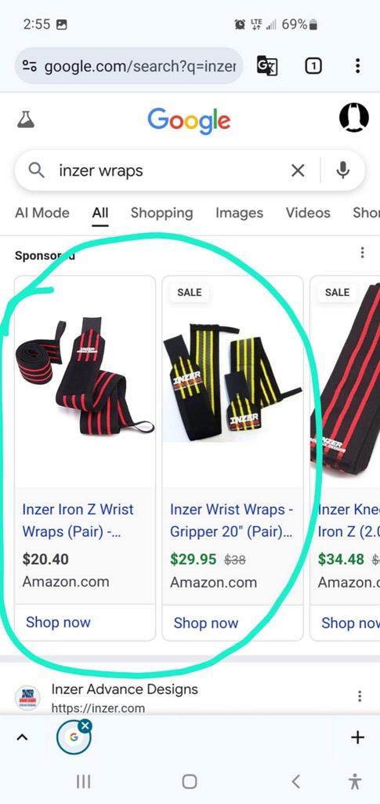 | 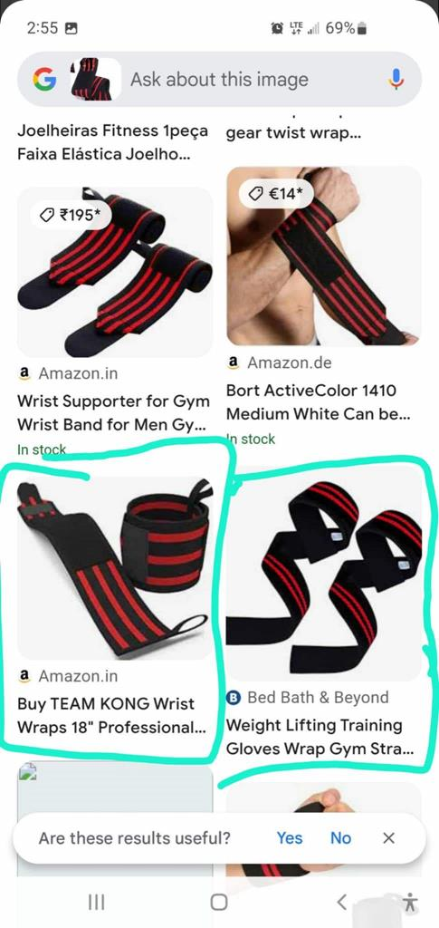
Page 6
11. Helpful comparisons: “Other” Wraps
“Zoom View”: Selected Inzer wraps | “Zoom-View” of Selected “other” wraps
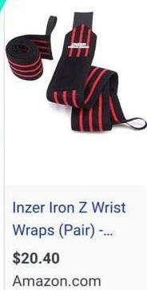  Inzer Wrist Wraps | 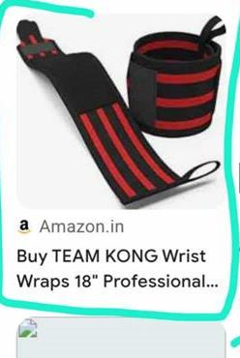  TEAM KONG Wrist Wraps | 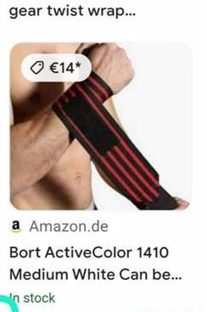  Bort 'twist' Wrist Wraps
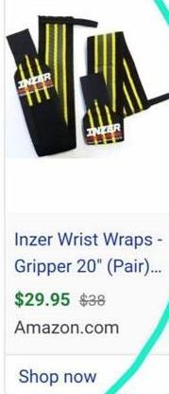  Inzer Wrist Wrap Gripper (Pair) | 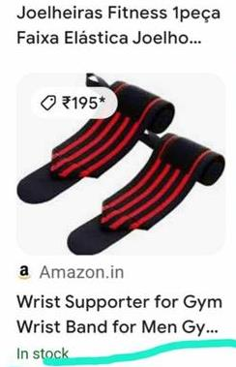  Joelheiras Wrist Band | 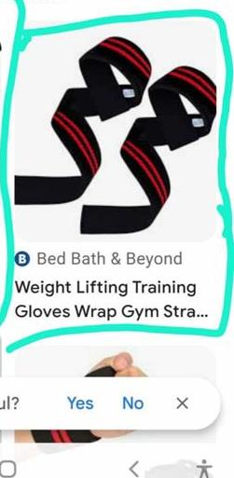  Bed Bath & Beyond Glove Wraps
  Inzer Knee Wraps | 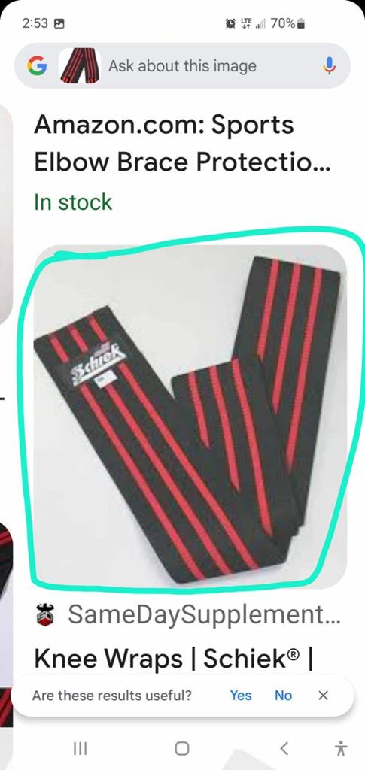  Schiek Knee Wraps | 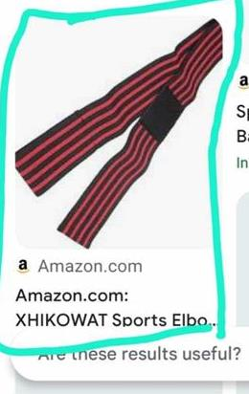  XHIKOWAT Elbow Wraps
Page 7
12. Helpful comparisons: Inzer vs. Mathis Wraps
“Zoom View”: Selected Inzer wraps | “Zoom-View” of Selected “other” wraps
Inzer Wrist Wraps | 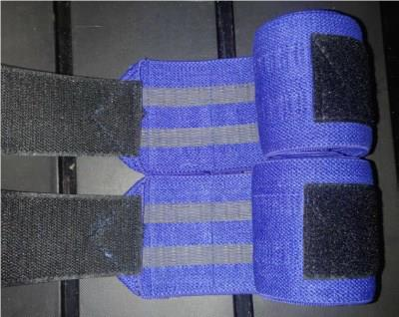  Mathis Wrist Wraps
Inzer Wrist Wrap Gripper (Pair) | 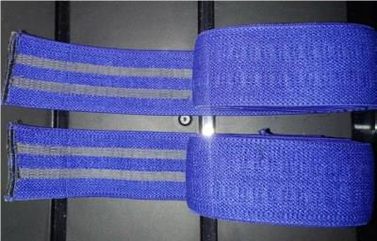  Mathis Elbow Wraps
Inzer Knee Wraps | 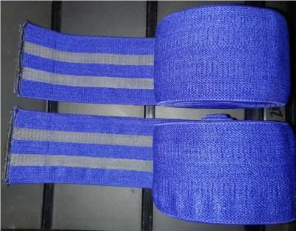  Mathis Knee Wraps
Page 8
13. Discussion
At this point, not much discussion is needed: It seems obvious even to the uninitiated layman that Inzer's design is exceedingly generic (lines, circles, zig-zags, etc.), and Mathis' “can't patent a circle” design is solid. In fact, her wraps are markedly different (in colour), and, if anything, Inzer should be suing every wrap manufacturer in the world, as they are all similar to his – and vice versa. However, this line of reasoning doesn't hold water because geometric shapes, like Inzer uses, can not be patented and should probably be declared invalid: all the wraps are starting to look the same after a while.
Of course, if Mathis had made wraps with the name “INZER WRAPS” on them, then – yes – this would be a problem. And, to be fair, Inzer's brand name should not be copied. However, here, it appears that, for whatever unknown reason (giving him the benefit of the doubt that this may have been an honest mistake on his part), his legal team is not representing him well insofar as they are over-reaching and attempt to patent generic designs: Courts protect novel applications, not just merely generic shapes. Diamond v. Chakrabarty, 447 U.S. 303 (1980)

14. Conclusion
All people are inherently important, valuable, and valued – and have inherent rights to fair treatment under the law – including both plaintiff and defendant. That said, unless there was something overlooked, the generic design of plaintiff's products is not patentable, and he should be denied relief here, relief should issue for defendant, and plaintiff should focus on marketing and sales of his items as it, without any distractions over unnecessary patent issues.

Page 9
14. CERTIFICATE OF SERVICE
I certify that on this 26TH day of June 2025 the foregoing document was served on all parties or their counsel of record through the CM/ECF system if they are registered users (if CM/ECF is available to me) or, if they are not, by placing a true and correct copy in the United States mail, postage prepaid, to their address of record. I further certify that I'm serving all parties and This Honourable Court by four (4) methods: (1.) USPS mail, (2.) e-mail, (3.) CM/ECF (if possible), and via (4.) public posting on my web-ring and in prominent online powerlifting communities in alignment with the subject-matter of this lawsuit involving John Inzer and April Mathis, two prominent powerlifters known for breaking numerous world records throughout their respective careers.

Service List:

United States District Court, Southern District, Office of the Clerk
Potter Stewart U.S. Courthouse, Room 103
100 East Fifth Street, Cincinnati, Ohio 45202
Email: Clerks_Office@ohsd.uscourts.gov
Office Hours: 9:00-4:00 Monday-Friday
Phone: (513) 564-7500
Jury Phone: 513-564-7522
Email: ohsd_cinjury@ohsd.uscourts.gov

Assigned Judge: Hon. Jeffery P. Hopkins, (513) 564-7540
Courtroom Deputy: Karli Colyer, (513) 564-7541
Potter Stewart U.S. Courthouse, Room 810
100 East Fifth Street, Cincinnati, OH 45202

Inzer Advance Designs, Inc., 124 W. Tyler St., Longview, TX 75606

Dinsmore & Shohl LLP, 255 E. Fifth St. # 1900, Cincinnati, OH 45202
(513) 977-8246 phone / (513) 977-8141 fax / Oleg.Khariton@dinsmore.com

Mark D. Schneider (Michigan Bar No. P55253, pending admission pro hac vice)
Dinsmore & Shohl LLP, 755 W. Big Beaver Rd. # 1900, Troy, MI 48084
(248) 203-1615 phone / (248) 647-5210 fax / Mark.Schneider@Dinsmore.com

April Mathis d/b/a Mathis Enterprises / AMathis01@gmail.com
1850 Union Hill Rd., Peebles, OH 45660

Dated: Thursday, June 26, 2025 Respectfully Submitted,

/s/ _Gordon Wayne Watts_ (electronic) /s/ ________________________ (physical)
Gordon Wayne Watts, Amicus Curiae, 2046 Pleasant Acre Drive, Plant City, FL 33566-7511 Official URL's: https://ContractWithAmerica2.com ; Gordon@ContractWithAmerica2.com
http://GordonWatts.com / http://GordonWayneWatts.com
(863) 687-6141 phone / (863) 688-9880 text / Gww1210@GMail.com
LAYMAN OF THE LAW: Gordon Wayne Watts, PRO SE / PRO PER
[*] Mr. Watts, acting as his own counsel, is not a lawyer.

Page 10
INDEX TO THE EXHIBITS
Instrument Docket / Tab#
OpenPowerlifting listing for John Inzer Exhibit-A
OpenPowerlifting listing for April Mathis Exhibit-B
Gym Video of Watts: Powerlifting Progress Exhibit-C
Court's 4-3 split decision re Watts' Terri Schiavo petition Exhibit-D
Court's 7-0 unanimous decision re Gov. Bush's Schiavo petition Exhibit-E
Verification that Watts filed Amicus with consent in US 11TH CCA Exhibit-F
Court Order granting Watts' motion to file amended brief per above Exhibit-G
Verification that Watts was only non-lawyer allowed to file here Exhibit-H
Documentation that Watts is holder of a Registerded Trademark Exhibit-I
Gym Video documenting that Watts personally knows Mathis Exhibit-J

Page 11
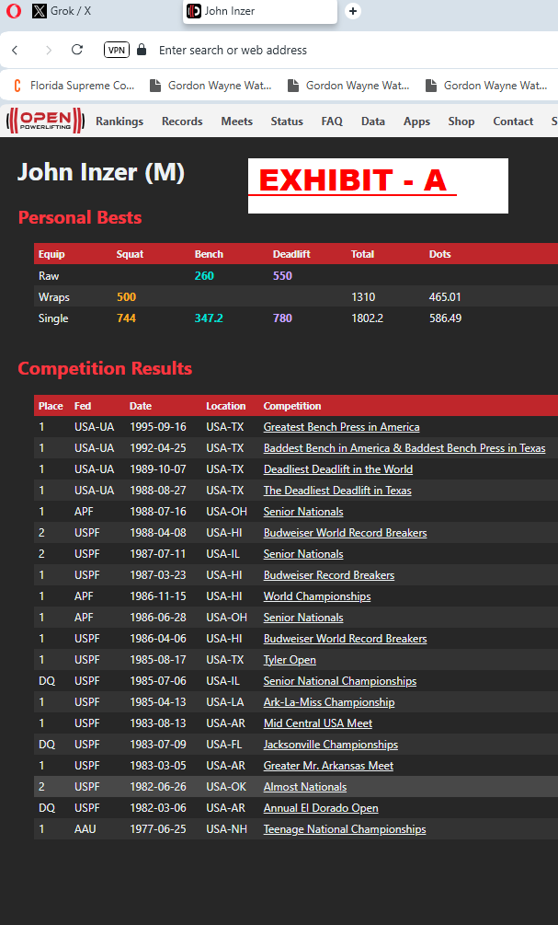
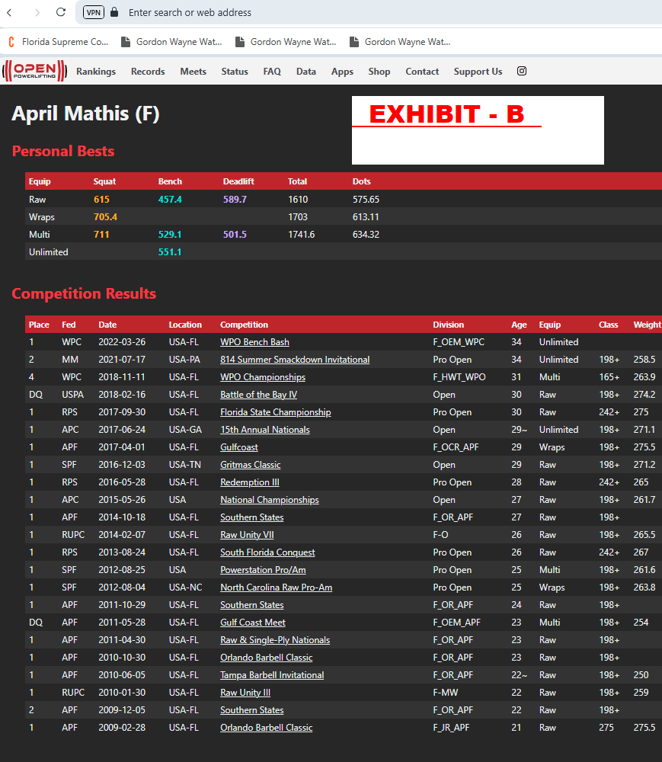
* https://www.openpowerlifting.org/u/johninzer
* https://www.openipf.org/u/johninzer
* https://en.allpowerlifting.com/lifters/USA/inzer-john-8489/

* https://www.openpowerlifting.org/u/aprilmathis
* https://en.allpowerlifting.com/lifters/USA/mathis-april-87766/
* https://barbend.com/april-mathis-705lb-squat/
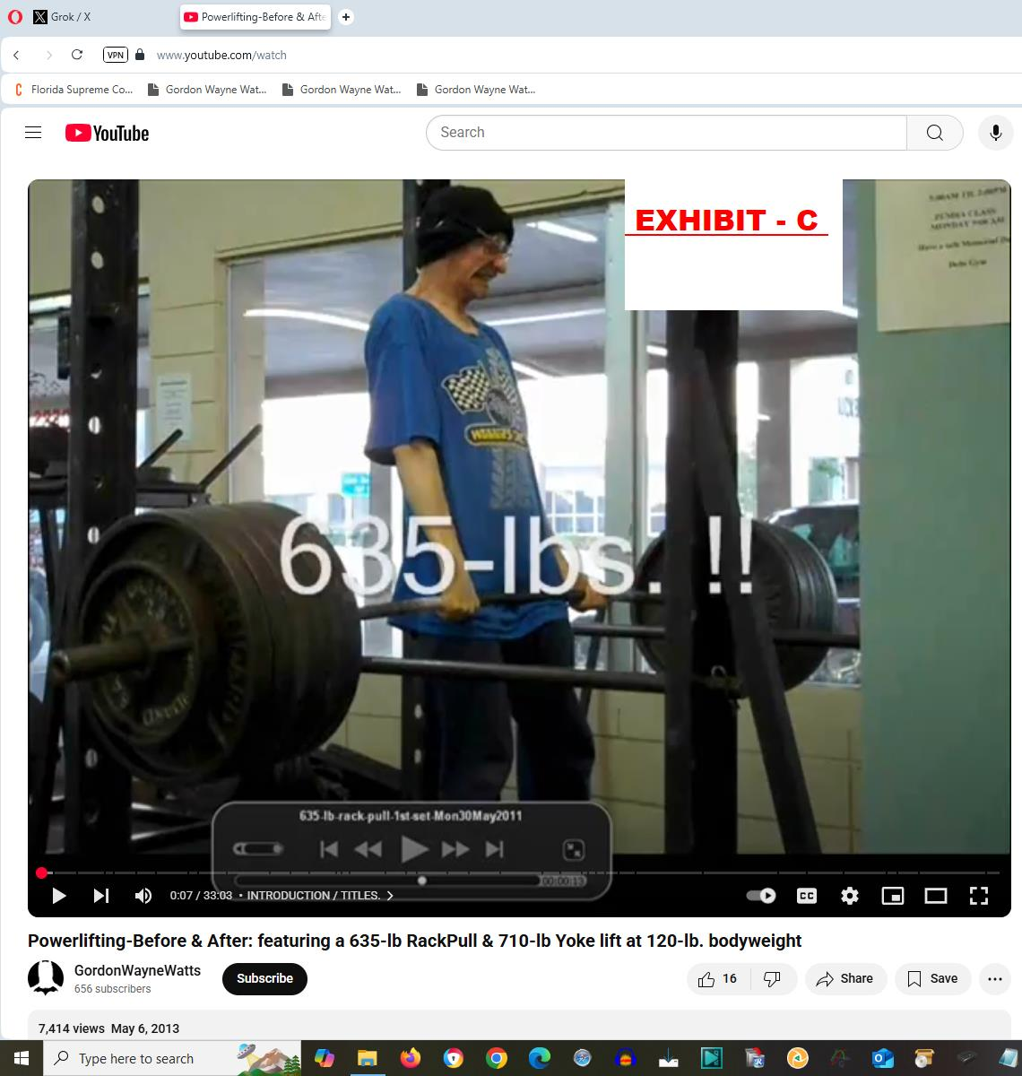
Power Lifting

https://www.youtube.com/watch?v=p8ekHA4OU_E

https://gordonwatts.com/FannyDeregulation/Powerlifting_BeforeAndAfter_710lbYoke_635Rack.mp4

https://gordonwaynewatts.com/FannyDeregulation/Powerlifting_BeforeAndAfter_710lbYoke_635Rack.mp4

https://contractwithamerica2.com/FannyDeregulation/Powerlifting_BeforeAndAfter_710lbYoke_635Rack.mp4

https://web.archive.org/web/20230704061812/https://contractwithamerica2.com/FannyDeregulation/Powerlifting_BeforeAndAfter_710lbYoke_635Rack.mp4

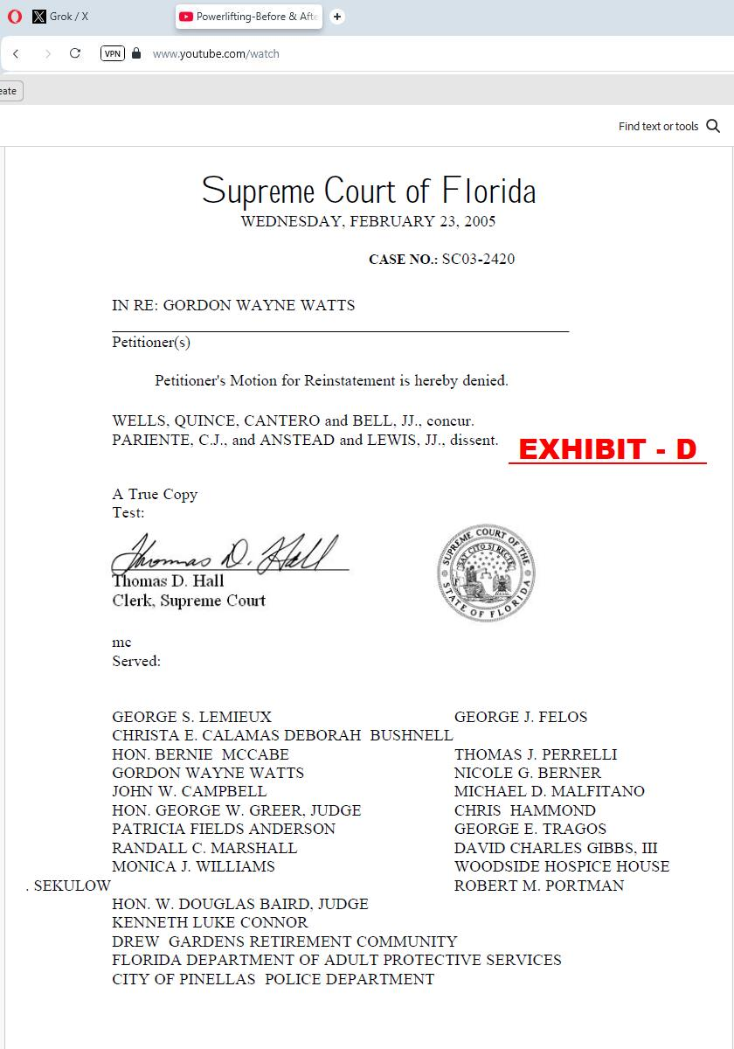
[1] In Re: GORDON WAYNE WATTS (as next friend of THERESA MARIE 'TERRI' SCHIAVO), No. SC03-2420 (Fla. Feb.23, 2005), denied 4-3 on rehearing. (Watts got 42.7% of his panel) https://www.floridasupremecourt.org/clerk/dispositions/2005/2/03-2420reh.pdf
[2] In Re: JEB BUSH, GOVERNOR OF FLORIDA, ET AL. v. MICHAEL SCHIAVO, GUARDIAN: THERESA SCHIAVO, No. SC04-925 (Fla. Oct.21, 2004), denied 7-0 on rehearing. (Bush got 0.0% of his panel before the same court)
https://www.floridasupremecourt.org/clerk/dispositions/2004/10/04-925reh.pdf
[3] Schiavo ex rel. Schindler v. Schiavo ex rel. Schiavo, 403 F.3d 1223, 2005 WL 648897 (11th Cir. Mar.23, 2005), denied 2-1 on appeal. (Terri Schiavo's own blood family only got 33.3% of their panel on the Federal Appeals level) https://media.ca11.uscourts.gov/opinions/pub/files/200511556.pdf
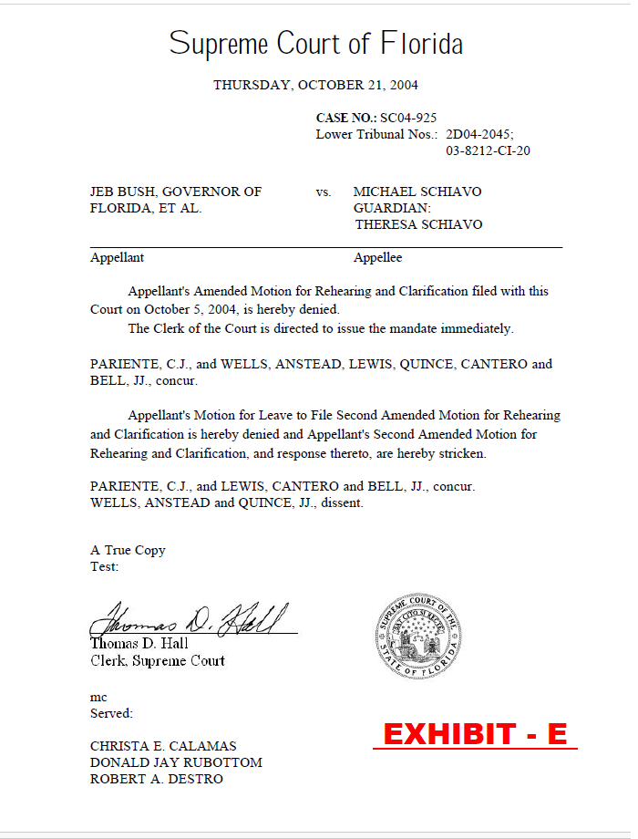
** Watts used a Class II Felony Argument (denial of food/water medical care), instead of Bush's “feeding tube” argument, and thus picked up more votes in Florida's High Court.

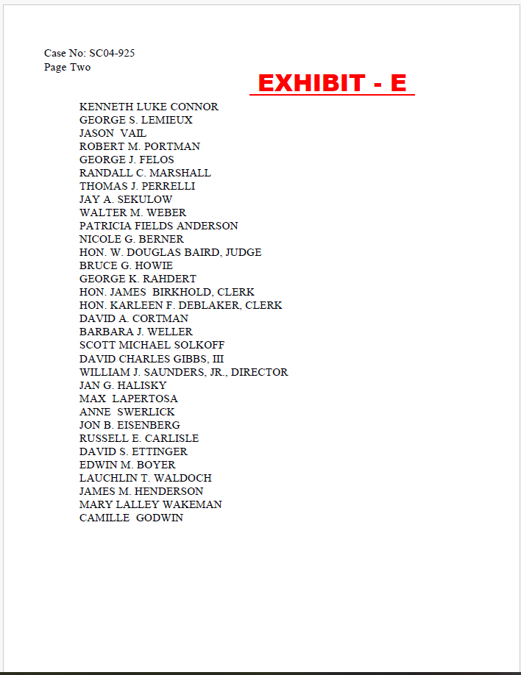
Cf: https://gordonwatts.com/TerriSupremeCourt.pdf
Cf: https://gordonwaynewatts.com/TerriSupremeCourt.pdf
Cf: https://archive.ph/2ievq
Cf: https://web.archive.org/web/20241203110023/https://gordonwaynewatts.com/TerriSupremeCourt.pdf
Cf: https://web.archive.org/web/20220425055032/https://gordonwaynewatts.com/TerriSupremeCourt.html
Links above are to a similar, and contemporary, but more-updated version (slight tweaks) of what was filed at the state level. ** Watts used a Class II Felony Argument (denial of food/water medical care), instead of Bush's “feeding tube” argument, and thus picked up more votes in Florida's High Court.

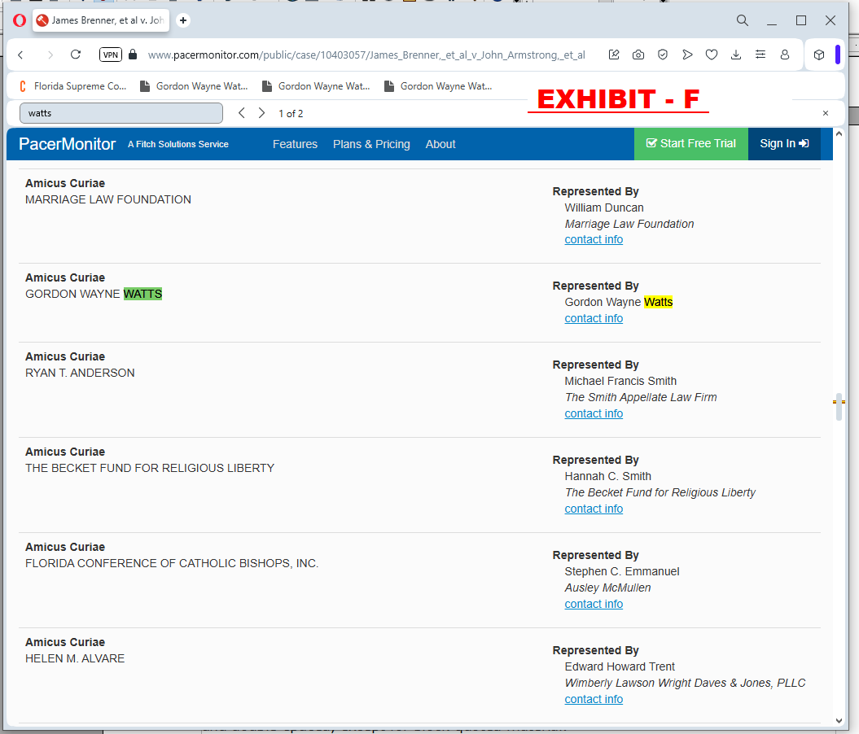

Consolidated Appeals Docket: 11th U.S. Circuit Court of Appeals
Case #: 14-14061 (James Brenner, et al v. John Armstrong, et al) Appeal From: N.D. of Fla. before Robert L. Hinkle, U.S. Dist. Judge: 4:14-cv-00107-RH-CAS
Case #: 14-14066 (Sloan Grimsley, et al v. John Armstrong, et al) Appeal From: N.D. of Fla. before Robert L. Hinkle, U.S. Dist. Judge: 4:14-cv-00138-RH-CAS

Amicus Curiae, GORDON WAYNE WATTS
Represented By: Gordon Wayne Watts
Brenner v. Armstrong, No. 14-14061 and 14-14066
(U.S. Eleventh Circuit, Sep. 19, 2014)

https://www.pacermonitor.com/public/case/10403199/Sloan_Grimsley,_et_al_v_John_Armstrong,_et_al

Watts told the Federal Appeals court that allowance of same-sex marriage risked opening the door to polygamy under Equal Protection (polygamy has even more historical precedent than same-sex marriage), but – on the other hand, The Court should leverage its full resources to ensure that gay citizens NOT be mistreated, as they sometimes are (denied hospital visitation, difficulty in naming a same-sex partner in survivor-ship life insurance, etc.: Watts argued that a person should be able to name anyone to his/her will, with no regard to their sexual orientation.) – and that gay citizens must NOT be mistreated in any way – regardless of how the same-sex marriage ruling went.
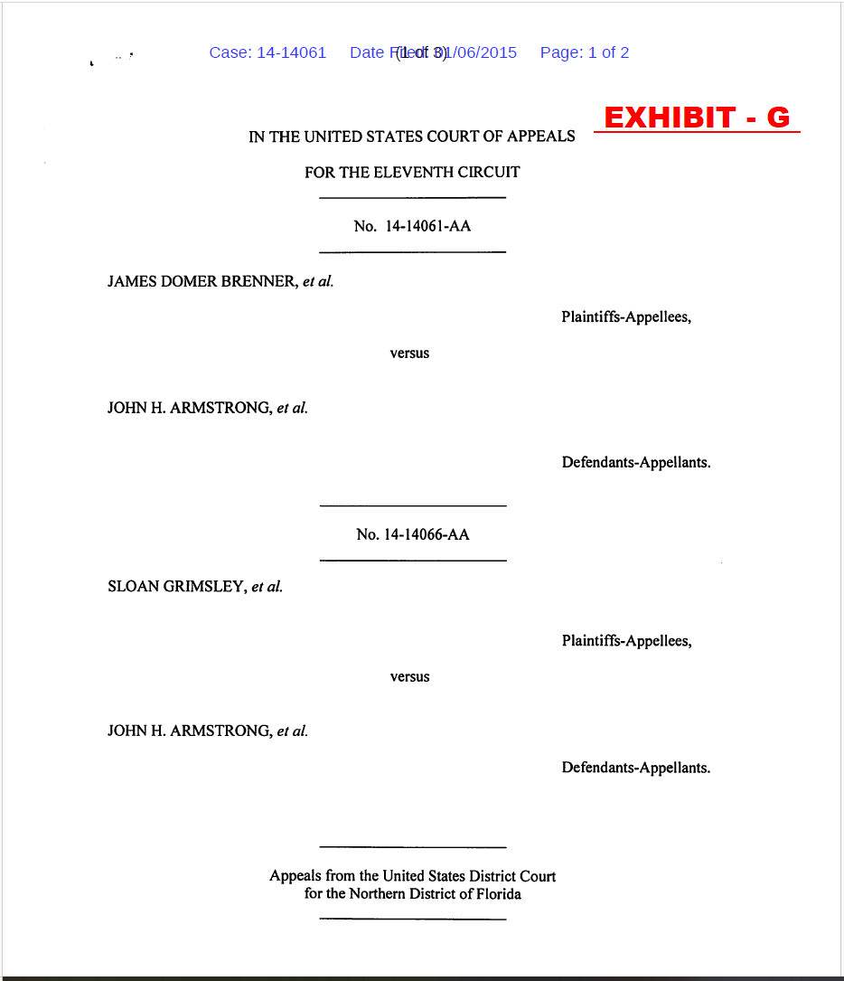
Consolidated Appeals Docket: 11th U.S. Circuit Court of Appeals
Case #: 14-14061 (James Brenner, et al v. John Armstrong, et al) Appeal From: N.D. of Fla. before Robert L. Hinkle, U.S. Dist. Judge: 4:14-cv-00107-RH-CAS
Case #: 14-14066 (Sloan Grimsley, et al v. John Armstrong, et al) Appeal From: N.D. of Fla. before Robert L. Hinkle, U.S. Dist. Judge: 4:14-cv-00138-RH-CAS

Amicus Curiae, GORDON WAYNE WATTS, Represented By: Gordon Wayne Watts
Brenner v. Armstrong, No. 14-14061 and 14-14066
(U.S. Eleventh Circuit, Sep. 19, 2014)
https://www.pacermonitor.com/public/case/10403199/Sloan_Grimsley,_et_al_v_John_Armstrong,_et_al
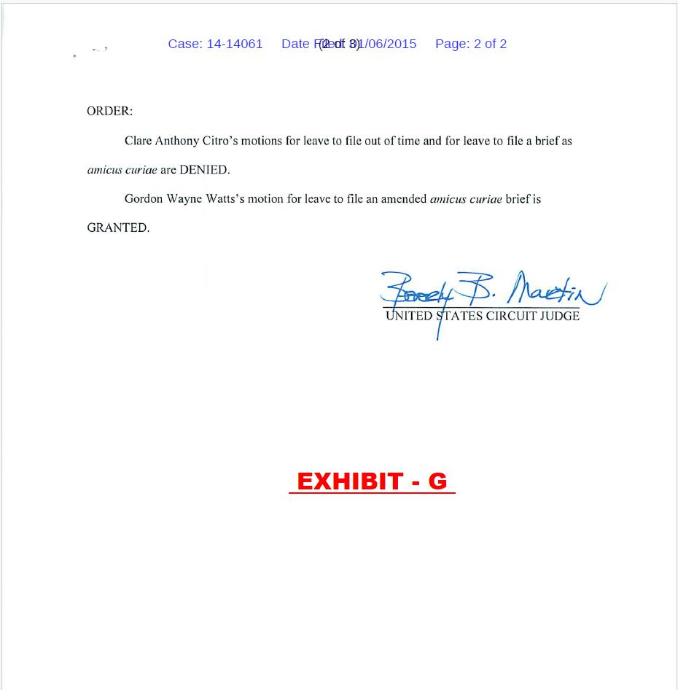
Watts told the Federal Appeals court that allowance of same-sex marriage risked opening the door to polygamy under Equal Protection (polygamy has even more historical precedent than same-sex marriage), but – on the other hand, The Court should leverage its full resources to ensure that gay citizens NOT be mistreated, as they sometimes are (denied hospital visitation, difficulty in naming a same-sex partner in survivor-ship life insurance, etc.: Watts argued that a person should be able to name anyone to his/her will, with no regard to their sexual orientation.) – and that gay citizens must NOT be mistreated in any way – regardless of how the same-sex marriage ruling went.

* https://gordonwatts.com/DOCKET-GayMarriageCase.html
* https://gordonwaynewatts.com/DOCKET-GayMarriageCase.html
* https://contractwithamerica2.com/#staff
* https://archive.vn/5YKAc
* https://web.archive.org/web/20181121192659/https://GordonWatts.com/DOCKET-GayMarriageCase.html

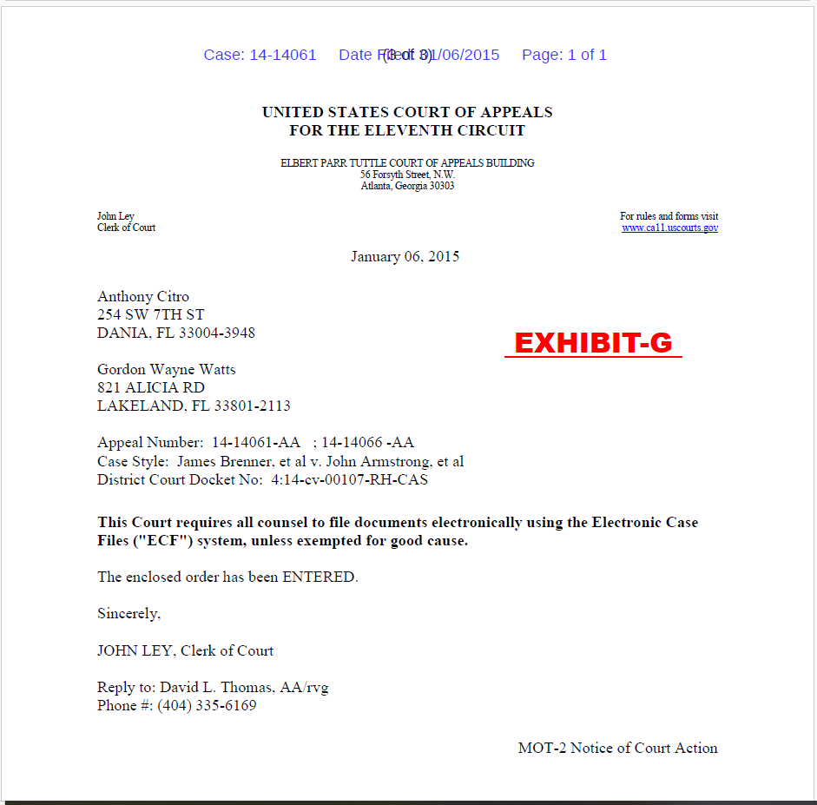
Exhibit-H
Verification that Watts was only non-lawyer allowed to file here : See links above to court docket.

Exhibit-I
Documentation that Watts is holder of a Registerded Trademark:

* https://www.trademarkia.com/owners/watts-gordon-wayne
* https://www.Google.com/search?q=contract+with+america+gordon+watts
* https://tsdr.uspto.gov/#caseNumber=90607682&caseSearchType=US_APPLICATION&caseType=DEFAULT&searchType=statusSearch
* https://ContractWithAmerica2.com
* https://tsdr.uspto.gov/#caseNumber=90607682&caseSearchType=US_APPLICATION&caseType=DEFAULT&searchType=statusSearch
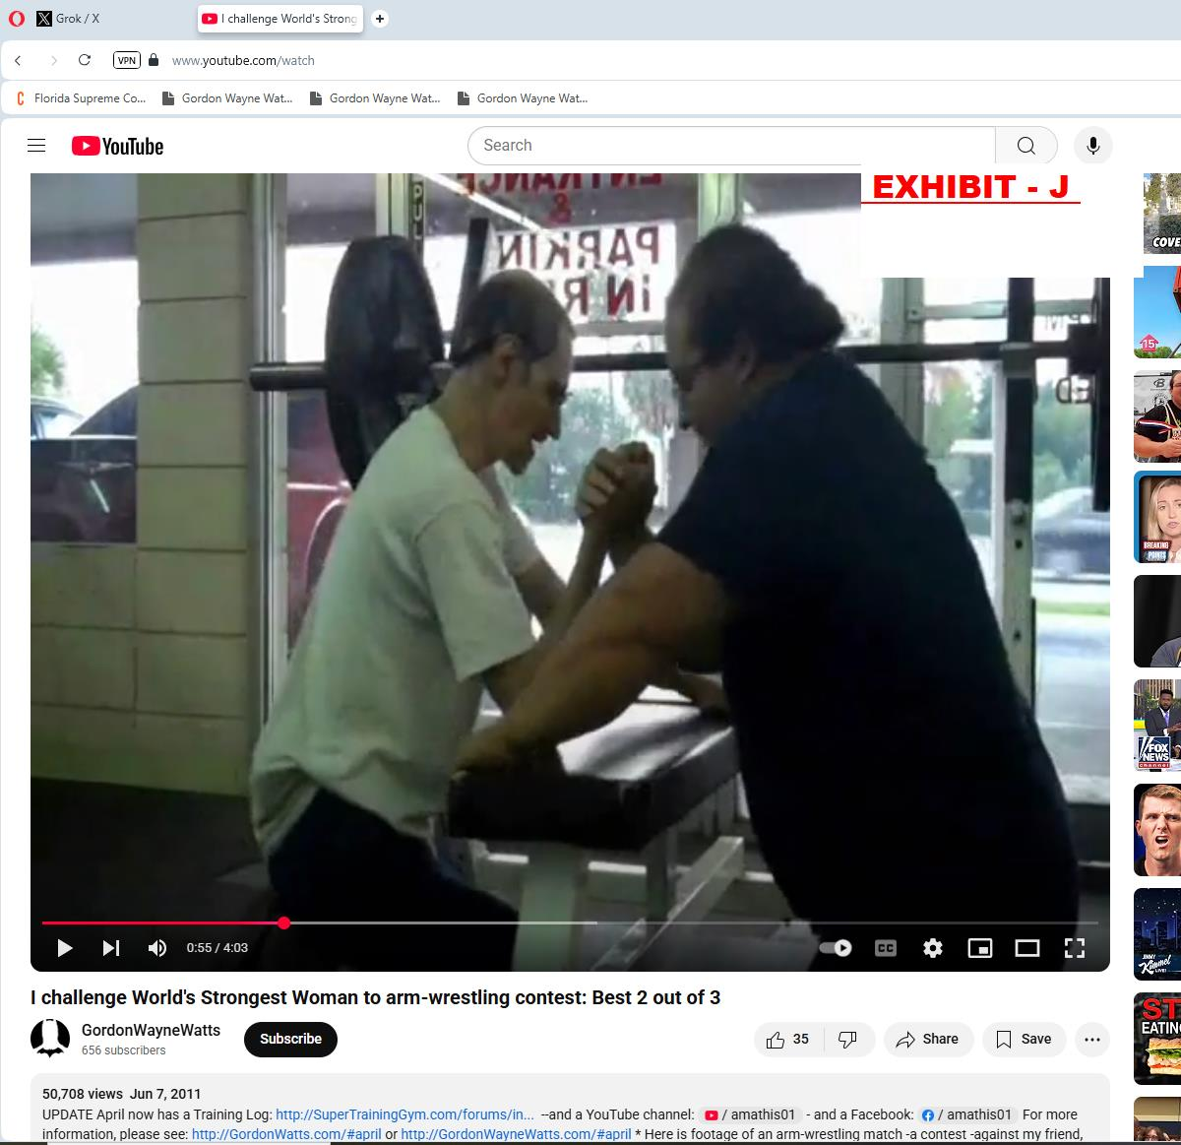

LINKS:
* https://www.youtube.com/watch?v=PjaMLYtj5l0
https://contractwithamerica2.com/FannyDeregulation/IChallengeWorldsStrongestWoman.mp4
* https://contractwithamerica2.com/FannyDeregulation/I_Challenge_WorldsStrongestWoman_Best-2-of-3_ArmWrestling_MP4.mp4
* https://gordonwatts.com/FannyDeregulation/IChallengeWorldsStrongestWoman.mp4
* https://gordonwatts.com/FannyDeregulation/I_Challenge_WorldsStrongestWoman_Best-2-of-3_ArmWrestling_MP4.mp4
* https://gordonwaynewatts.com/FannyDeregulation/IChallengeWorldsStrongestWoman.mp4
* https://gordonwaynewatts.com/FannyDeregulation/I_Challenge_WorldsStrongestWoman_Best-2-of-3_ArmWrestling_MP4.mp4
* https://web.archive.org/web/20220519035609/https://gordonwaynewatts.com/FannyDeregulation/I_Challenge_WorldsStrongestWoman_Best-2-of-3_ArmWrestling_MP4.mp4

